Experiment 5:
Create a table Customer (CustomerID , CustomerName, ContactNo, Address, City, PostalCode, Country) with CustomerID as PK

· Create a table Orders (OrderID, CustomerID, EmployeeID, OrderDate, ShipperID)with OrderID as PK and CustomerID, EmployeeID as FK from Customer and Employee table respectively

· Create a table Employees (EmployeeID LastName FirstName BirthDate Photo) with EmployeeID as PK
· Insert 5 tuples in each table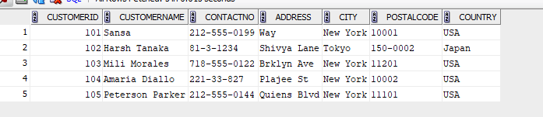
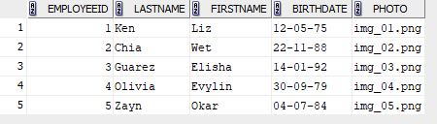
1: List all customers in ascending order by their names.
SELECT *
FROM Customer
ORDER BY CustomerName ASC;
o/p:
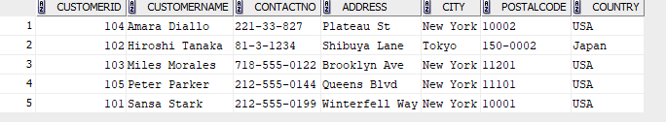
2: Retrieve a list of orders with the oldest ones appearing first, sorted by order date in ascending order.
SELECT *
FROM Orders
ORDER BY OrderDate ASC;..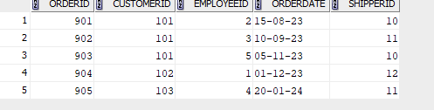
3: Find the employees who were born after 1980 and list them in descending order of their birthdates.
SELECT *
FROM Employees_55
WHERE BirthDate > date '1980-12-31'
ORDER BY BirthDate DESC;
o/p:
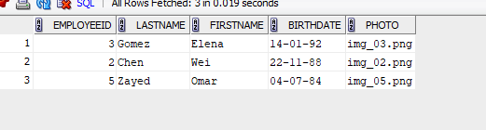
4: List orders placed by customers from 'USA' in descending order of the order date.
SELECT O.*
FROM Orders O
JOIN Customer C ON O.CustomerID = C.CustomerID
WHERE C.Country = 'USA'
ORDER BY O.OrderDate DESC;
o/p:
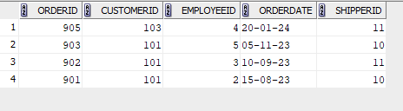
5: Calculate the total number of orders placed by each customer.
SELECT CustomerID, COUNT(OrderID) AS TotalOrders
FROM Orders
GROUP BY CustomerID;
o/p:
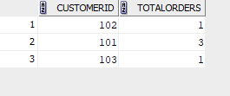
6: List the cities with the total number of customers.
SELECT City, COUNT(CustomerID) AS TotalCustomers
FROM Customer
GROUP BY City;

o/p:
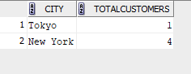
7: List customers who have placed more than 2 orders.
SELECT CustomerID, COUNT(OrderID) AS TotalOrders
FROM Orders
GROUP BY CustomerID
HAVING COUNT(OrderID) > 2;
o/p:
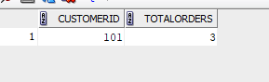
8: Display cities with more than 3 customers.
SELECT City, COUNT(CustomerID) AS TotalCustomers
FROM Customer
GROUP BY City
HAVING COUNT(CustomerID) > 3;
o/p:
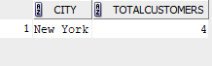
10:find customers who have placed more than one order:
SELECT CustomerID, COUNT(OrderID) AS Order_Count FROM Orders_55 GROUP BY CustomerID HAVING COUNT(OrderID) > 1;
o/p:
